一：Install EMMC LK(空片燒錄):

* **Baud rate : 460800**
* **按住ctrl+q，板子上电，进入烧录**

**串口设置**

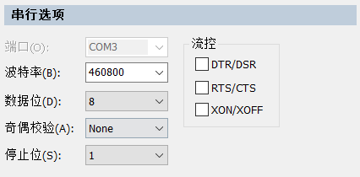

**secure-CRT为例**

* Power up, press Ctrl+q on console into rescue mode ,Command Prompt
* d/g/r>
* d/g/r>h
* Load HW setting bin via Hyper terminal, Y-moderm -G
* --- transfer HWsetting(build_scripts/lk/flash_writer/OUT_FILE/RTD1619B_hwsetting_BOOT_2DDR4_8Gb_s2133_final.bin) to flash ---
* d/g/r>d
* Load uboot bin(build_scripts/lk/flash_writer/OUT_FILE /uda_emmc.bind.bin) via Hyper terminal , Y-moderm -G
* --- transfer uboot to flash---
* d/g/r>g
* d/g/r>d
* Load uboot bin(build_scripts/lk/flash_writer/OUT_FILE /boot_emmc.bind.bin) via Hyper terminal , Y-moderm -G
* --- transfer uboot to flash---
* d/g/r>b1
* d/g/r>b2

secure-CRT图示：

1. 设置相应的参数 (460800, none)
2. 按板子开机键 ，同时 按ctrl + q

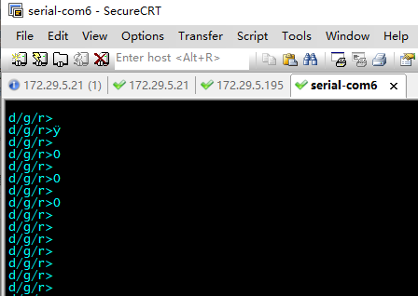

1. 按 'h' 传入RTD1619B_hwsetting_BOOT_2DDR4_8Gb_s2133_final.bin

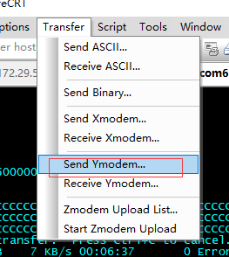

点击需要的文件，然后点add，然后点击ok

下一次传输其他文件，需要把add中之前的文件删除

二：EMMC uboot upgrade(升級更新)

Power up, press ESC on console to enter uboot64 shell

Realtek> usb start

Realtek> fatload usb 0:1 0x1500000 demo-0000-RTD1619B_2DDR4_8Gb_s2133-rtk_uboot_drm_smpv3-prod.bin

Realtek> go 0x1500000

lk中用Chain 0x1500000